GIS TRACKS FOOD PRODUCTS(SUPPLY2U)

SOFTWARE VERSION 1.0

**AUTHORS:**

1. IAN NDOLO MWAU
2. NEEMA OGAO
3. DAVID NZAMBULI
4. MAUREEN NYAGA
5. PHARIS KARIUKI

**ABSTRACT**

In the world we live in today, the agricultural sector continues to play a significant role in the growth of economies throughout the world. With the development of new technologies, it's imperative to take a look at how we can automate certain aspects of the value chain that starts from the farmer to the retailer selling the products. Specifically, we aim to address issues geographically.

Our software is currently using the following technology stack:

* ReactJS for the frontend
* Python Django for the backend
* Django REST Framework for API development
* PubNub for websocket management to ensure real time delivery of information\
* Leaflet as our main mapping library
* PostgreSQL as our Relational and geographical Database solution.

**INTRODUCTION**

Globally and especially in East Africa, agricultural supply chains, small-scale farmers, agro-dealers, and urban retailers face significant challenges in ensuring food products' efficient, sustainable distribution.

Consumers increasingly demand to know the origins of their food, and retailers require precise information to manage inventory and meet consumer demand. Inefficiencies in the agricultural supply chain lead to high post-harvest losses, inconsistent quality and availability of produce, and inflated prices due to multiple layers of intermediaries.

There is a critical need for a transformative geographical platform that seamlessly connects these stakeholders, prioritizing efficiency, sustainability, and profitability throughout the supply chain.

With this software, we're revolutionizing how agricultural supply chains operate from farm to retailer. Our innovative platform seamlessly integrates geolocation data of the farms, real-time transport monitoring, and actionable geographical data insights to empower stakeholders at every step of the supply chain. We aim to focus on efficiency, sustainability, and profitability, transforming how stakeholders connect and thrive in a dynamic market through a geographically holistic, data-driven, innovative approach.

**SOLUTION IMPLEMENTATION**

This section includes a sequenced description of key areas and functionalities of the software with screenshots to support relevant information.

1. **Login/SignUp:**

When the administrator loads the website at first, He is taken to the landing page.

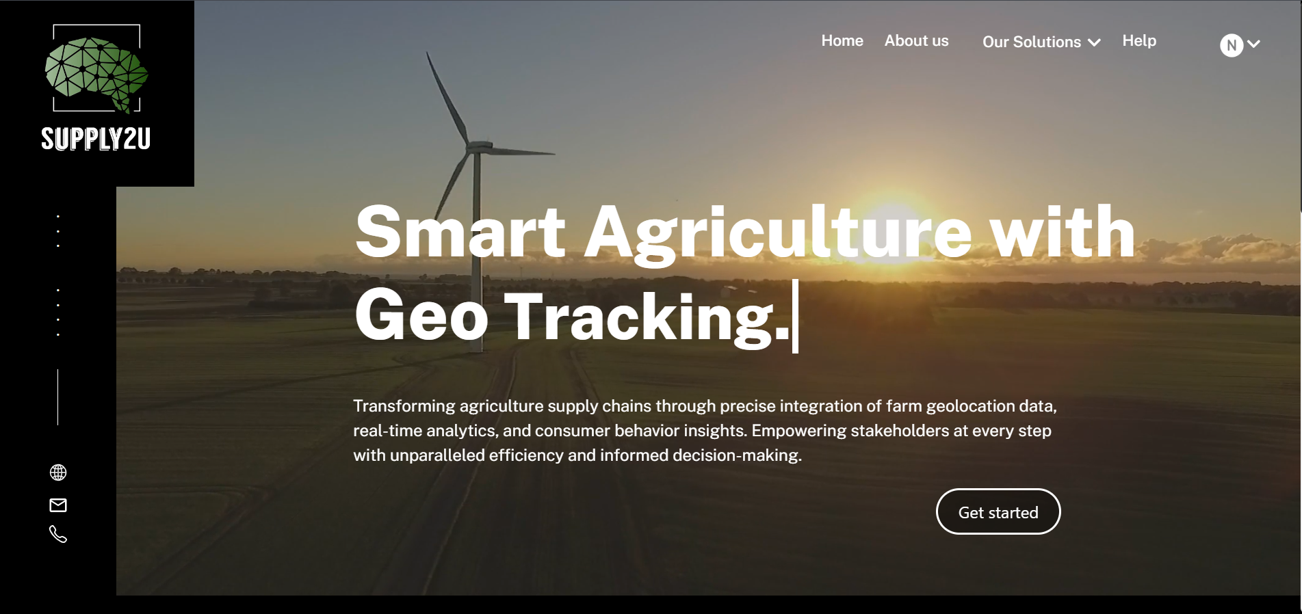Here they are provided with a concise description of what the website is about and then they proceed to create an account or log in to the platform through their credential or google work email:

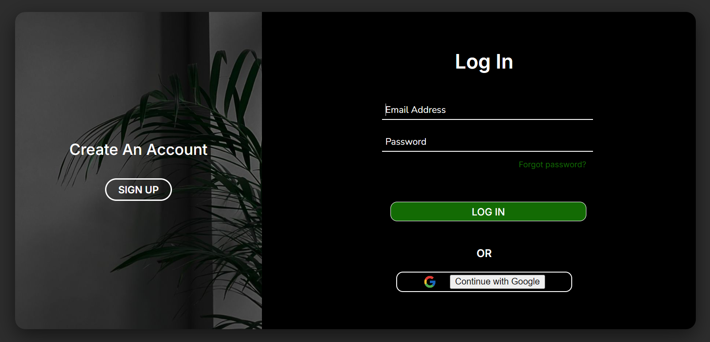

When the user is all logged in, they can proceed to choose any of the solutions they want to navigate to through the dropdown menu at the top-right corner:



1. **Field and Location Mapping.**

To view this functionality, the user navigates to the view Locations option where they are navigated to a page where they can visualize all the current mapped-out locations and fields on a map and a filter form on the left pane to filter out the content they see on the map:

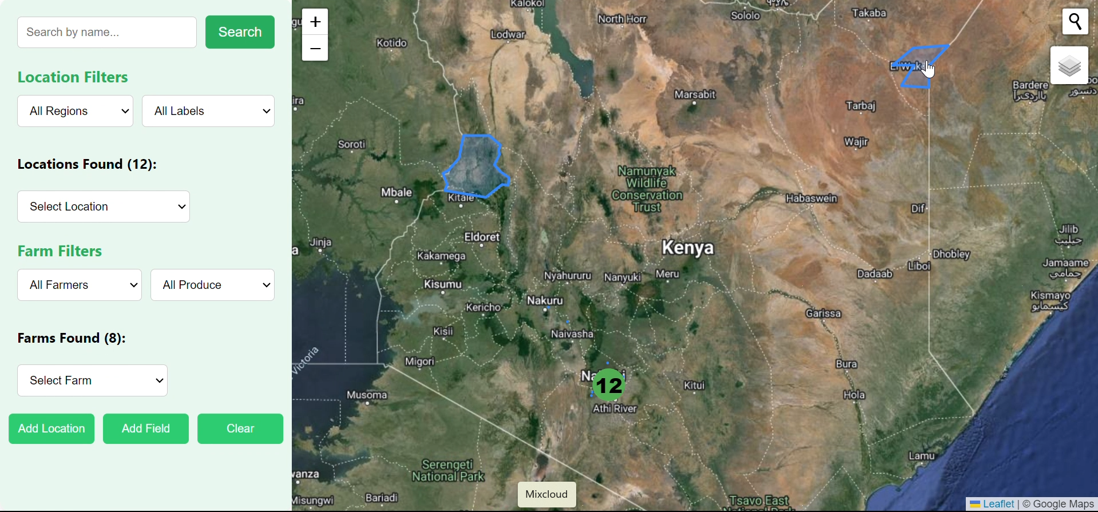

1. ***Adding Locations and Fields***

To add locations or fields to the map, the user clicks on the buttons at the bottom of the pane and chooses where they are navigated to the respective pages to enter the information:

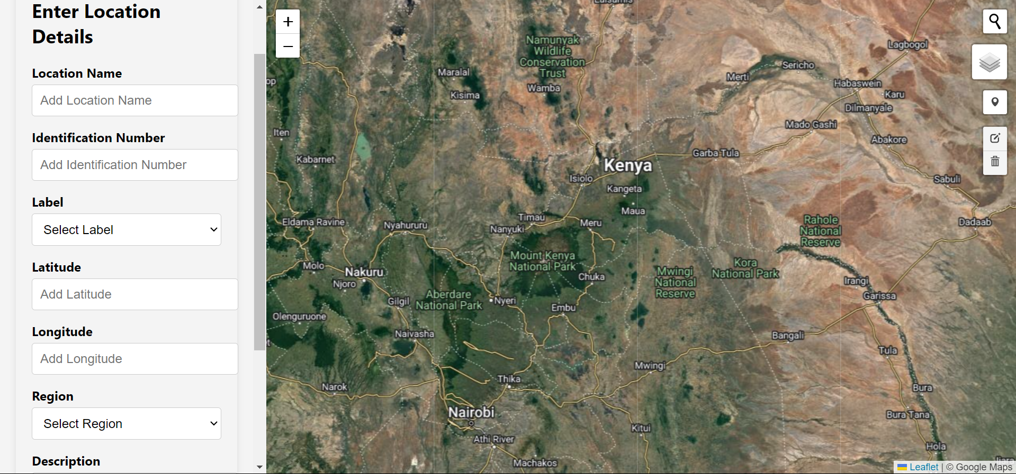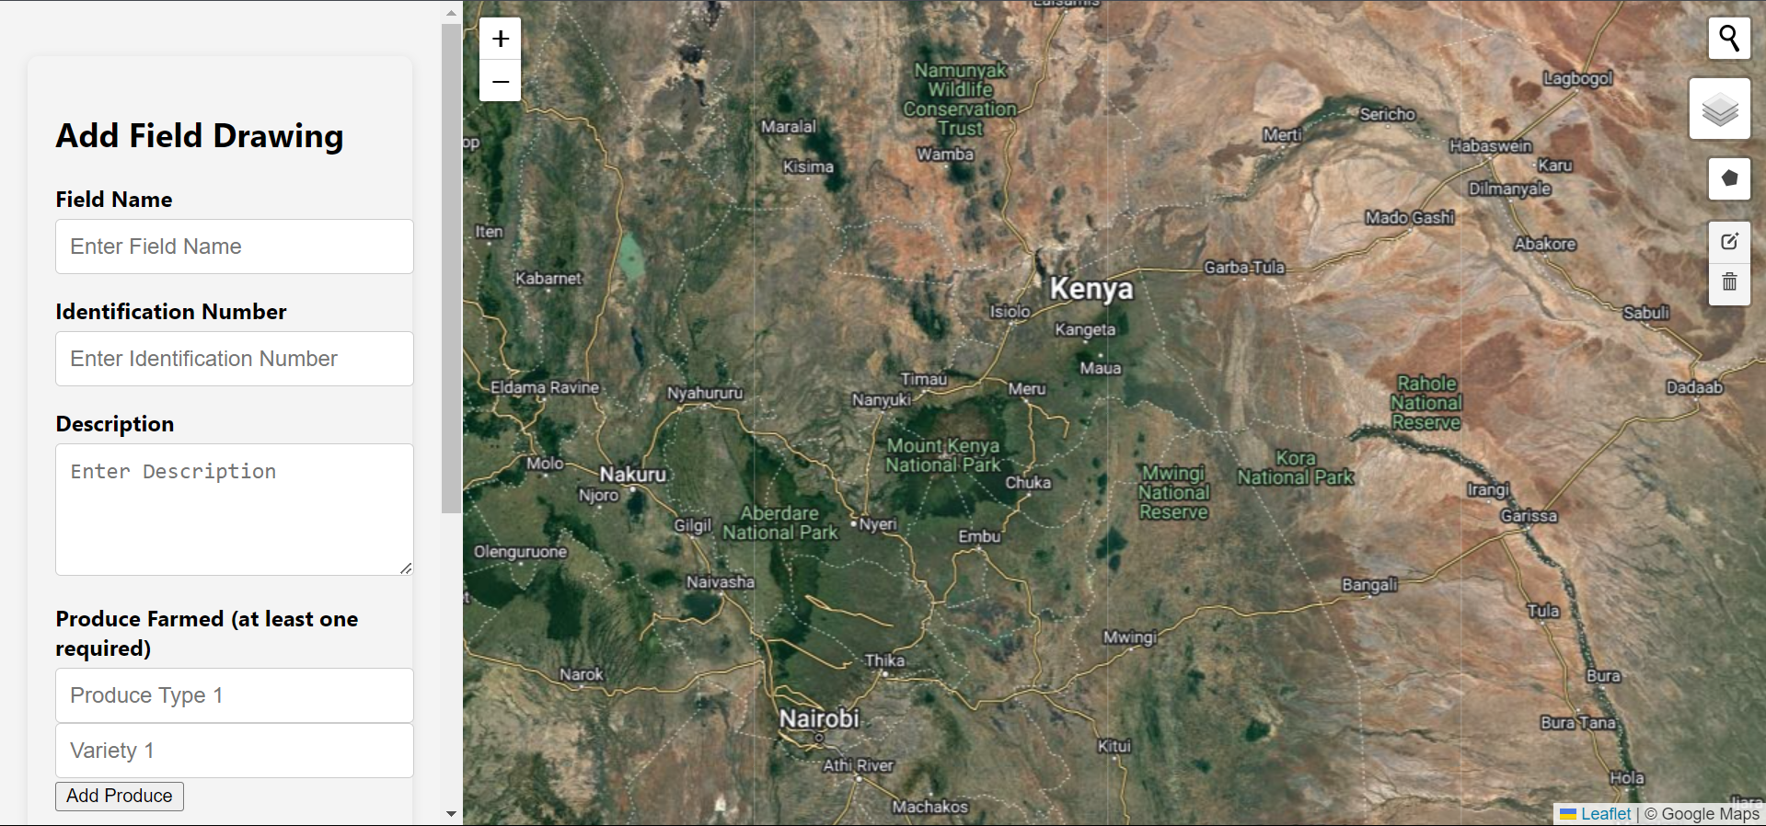

1. ***Updating Locations and Maps:***

To update the locations and maps already saved into the database, the user just has to click on the component they want to edit and choose the action to carry out:

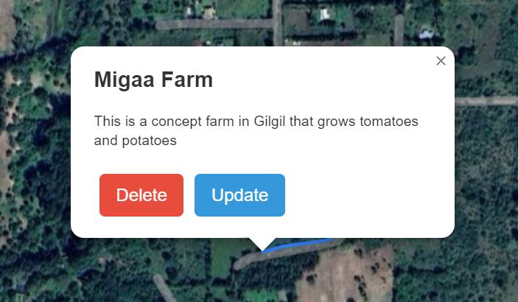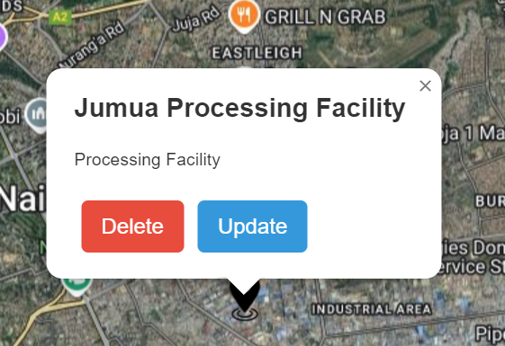

After clicking the update button, the user is taken to a where they can edit the information:

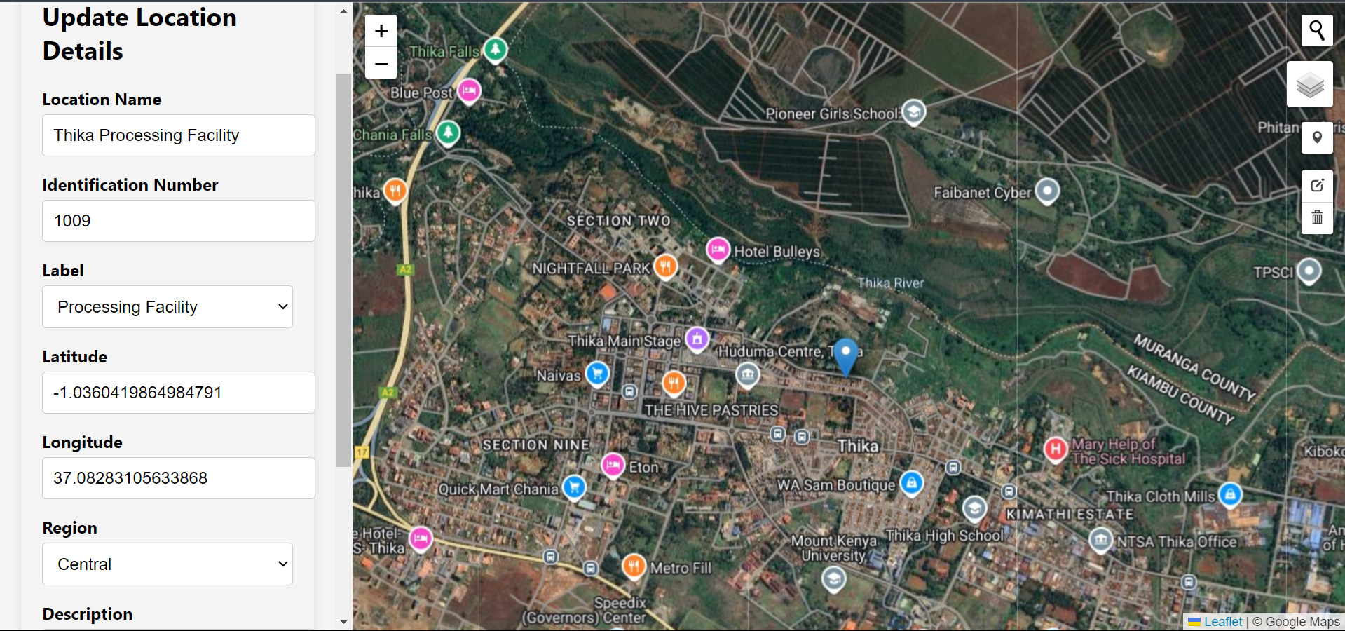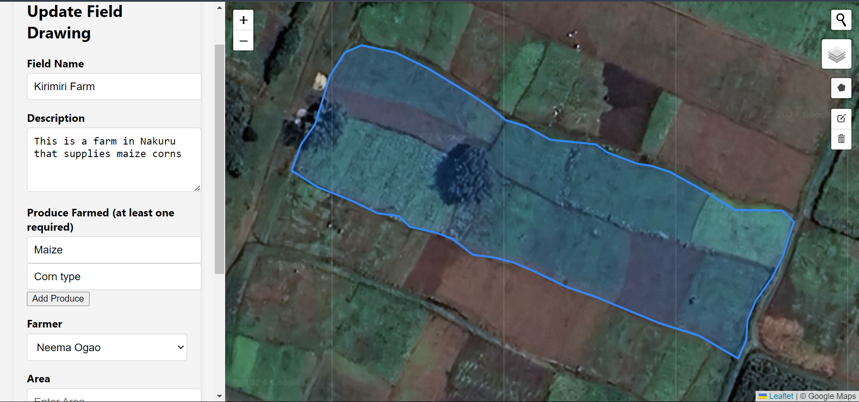

1. ***Filtering the data***

The user can also choose what they want to visualize on the map, by applying the filters provided on the information displayed from the database. For example, the user can choose to visualize only processing facilities:

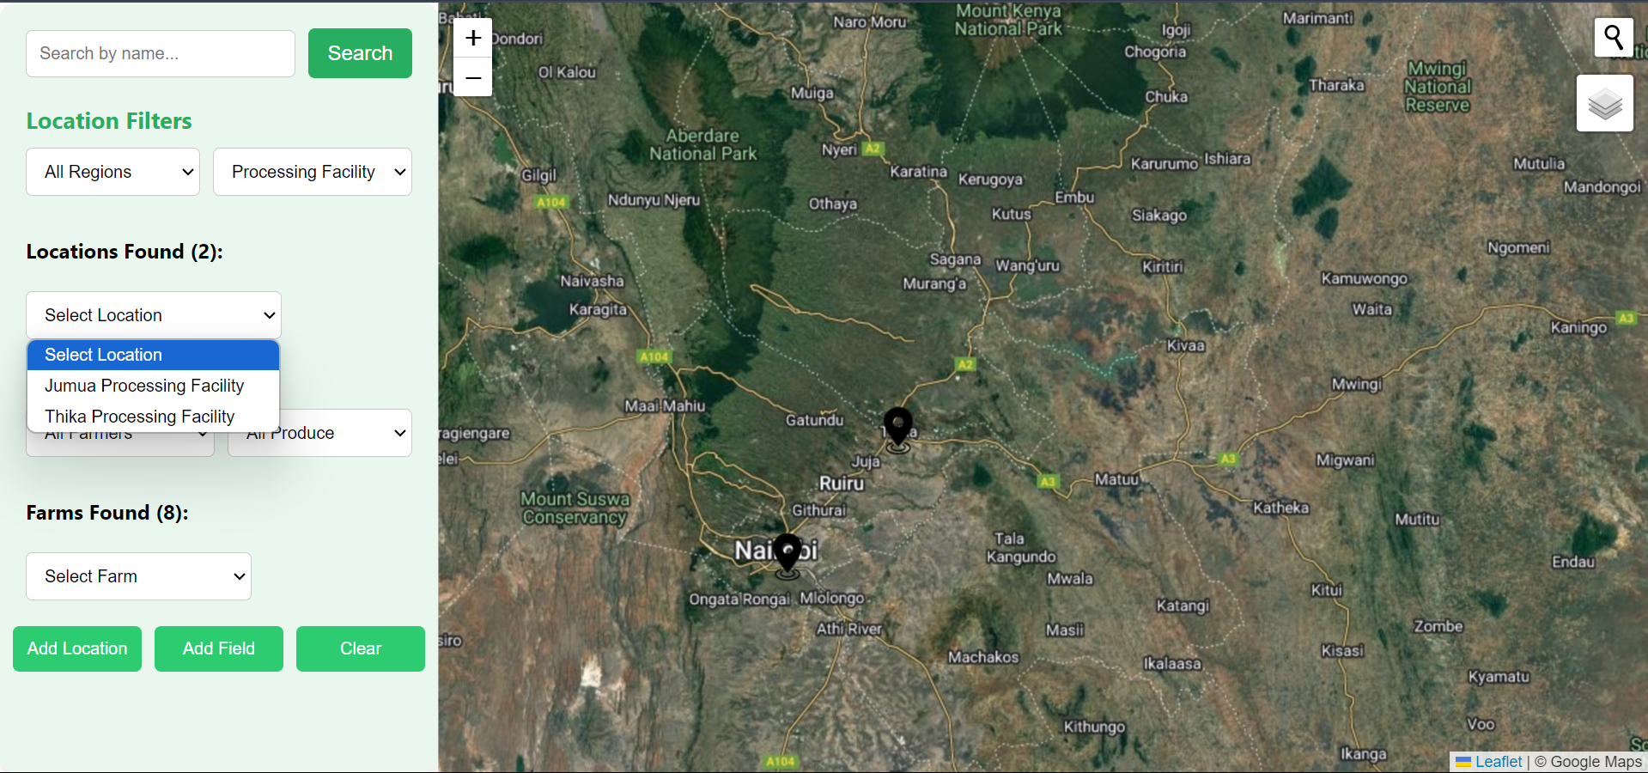

Similarly, the user can filter out farms that produce maize only:

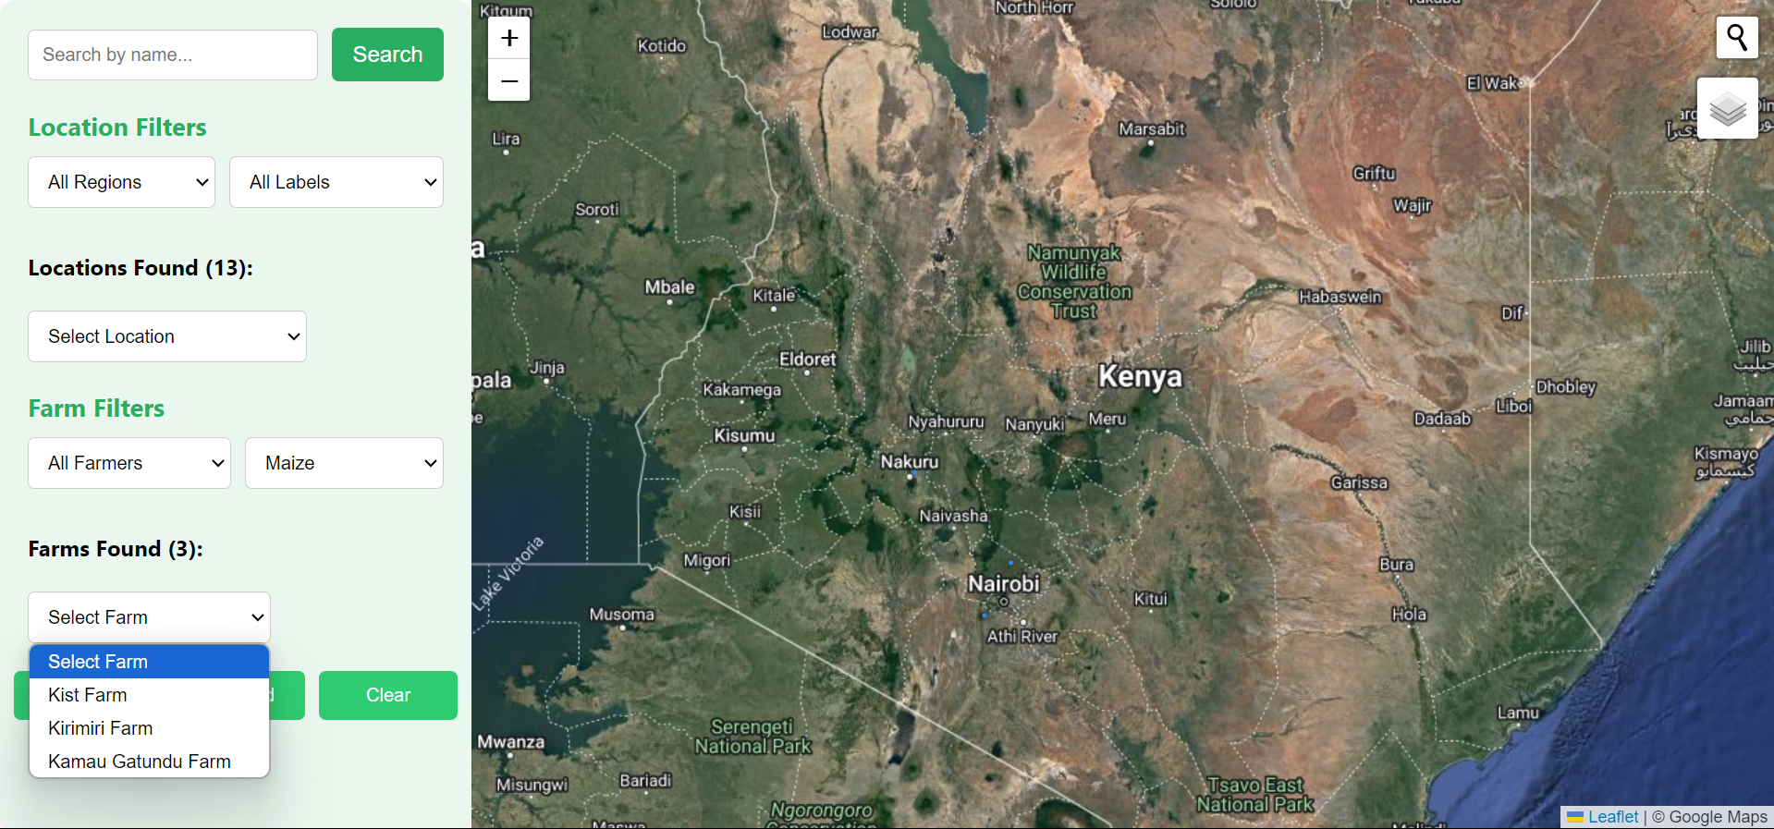

**PROJECT CODE LINKS.**

Portfolio website: [GITHUB PORTFOLIO WEBSITE CODE.](https://github.com/Ian386/UgaviBora)

Frontend GitHub repo: [FRONT END GITHUB REPO](https://github.com/OgaoNeema/Ugavi-Frontend)

Backend GitHub repo: [BACK END GITHUB REPO](https://github.com/Ian386/Ugavi-BackEnd)